CUMCM-2018 Problem B

Dynamic Scheduling Strategy for Intelligent RGV

An intelligent processing system is composed of 8 computer number controller (CNC) machines, one automatic Rail Guide Vehicle (RGV) with straight line track, one incoming belts, one discharge belts and other auxiliary equipment. RGV is a self-driving intelligent vehicle, which can run freely on fixed tracks. RGV can automatically control the direction and distance of movement according to instructions. RGV is able to complete loading and unloading and cleaning operations (see Appendix 1).
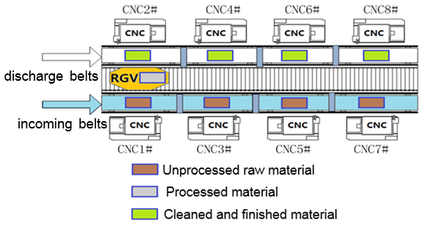
Figure 1: Schematic diagram of intelligent processing

For the following three situations：
(1) Material is processed in one process: each CNC is equipped with the same tool, and the material can be processed on any CNC.
(2) Material is processed in two processes: each material is processed successively by two CNCs with different tools.
(3) The CNC may fail (According to statistics: the probability of failure is about 1%), the troubleshooting (remove unfinished material manually and discard them) time is between 10~20 minutes, and the CNC joins the operation sequence immediately after the fault is excluded. The CNC failure must be considered respectively in situations (1) and (2).

Your team is asked to finish following two tasks.
Task one: For general processing problem, formulate the RGV dynamic scheduling model and give the corresponding algorithm.
Task two: The practicability of your model and the effectiveness of the algorithm are tested using the three sets of numerical values of the operational parameters in Table 1, and given the scheduling strategy of RGV and operation efficiency of the system. Please fill your specific results in the Excel spreadsheet of Appendix 2.

Table 1: The operation parameters of the intelligent processing system
(Time unit: second)
The Operation Parameters of the System | First Set | Second Set | Third Set
RGV move one unit time | 20 | 23 | 18
RGV move two units time | 33 | 41 | 32
RGV move three units time | 46 | 59 | 46
One process: CNC processing time of a material | 560 | 580 | 545
Two processes: CNC processing sequence 1 time of a material | 400 | 280 | 455
Two processes: CNC processing sequence 2 time of a material | 378 | 500 | 182
RGV time of one loading and unloading to CNC1#,3#,5#,7# | 28 | 30 | 27
RGV time of one loading and unloading to CNC2#,4#,6#,8# | 31 | 35 | 32
RGV cleaning and carrying out delivery time of a material | 25 | 30 | 25
Note: 8 hours of continuous operation for each working shift.

Appendix 1: The composition and operation process of intelligent machining system.
Appendix 2: The Excel spreadsheets of the results of the model (Please submit the complete spreadsheets as your paper’s appendix).

